Boat Guides

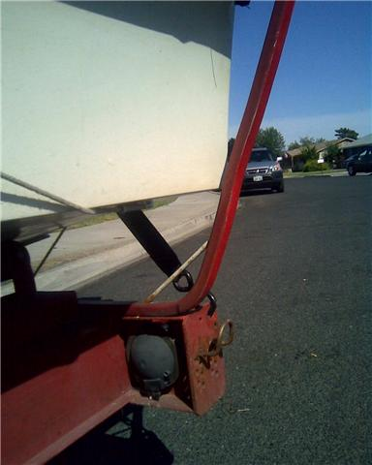
Here are a set of Home made boat guides that I salvaged from an old boat trailer

The boat guide appears to be made of ¼ inch thick galvanized (or stainless) steel 1 inch wide, with ¾ inch thick nylon (or plastic) glued to the galvanized steel.
The curves are hand bent.

Anyway they work really well for me and them seem to blend in with the original trailer design.
