Evinrude Trailer Parking Wheel

While on my way to the lake last weekend the spring on my trailer’s parking wheel assembly broke.

I replaced the spring and then though that I had better add something extra to the system just in case the spring breaks again.

Shown below is my added snap hook that prevents the wheel from falling down toward the road should the spring ever break again while the trailer is being towed.

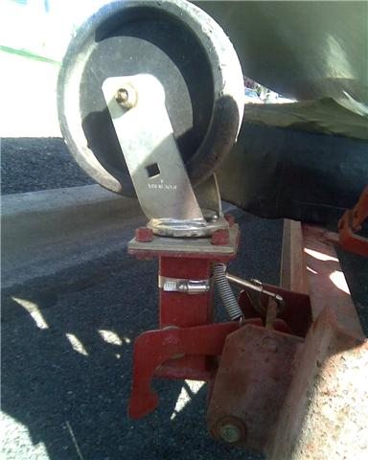
(Photo 1)
Parking wheel up:
Latch arm assembly in the Towing position.

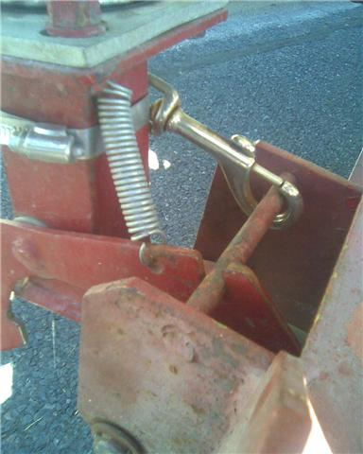
(Photo 2)
Parking wheel up:
Latch arm assembly in the Towing position.
***Note replacement Spring
and
Hose clamp with Bolt Snap Hook***

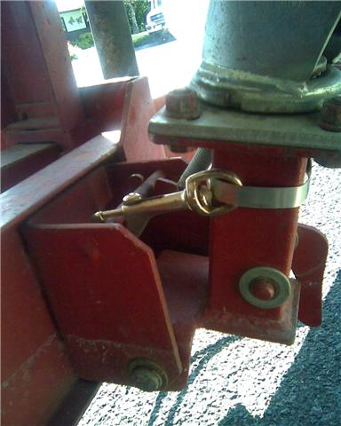
(Photo 3)
Parking wheel up:
Latch arm assembly in the Towing position.

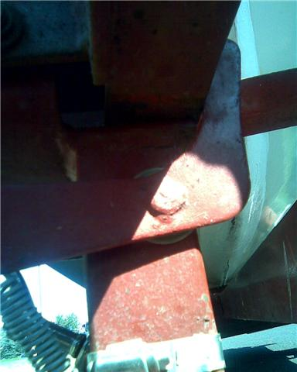
(Photo 4)
Parking wheel down:
Latch arm assembly in the Parking position.
***Viewed at street level looking up***

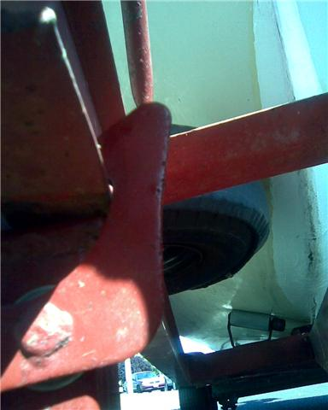
(Photo 5)
Parking wheel down:
Latch arm assembly in the Parking position.
***Viewed at street level looking up***

